PROGRAM CODE

#include <stdio.h>
int block[20],process[20],isAllocated[20]={0},allocated[20],b,p,choice,flag = 0;
void firstFit ();
void bestFit ();
void worstFit ();
int bwFinder (int startIndex, int pSize, int curValue, int mode);
void display ();
int main ()
{
printf ("Number of Blocks = ");
scanf ("%d", &b);
printf ("Size of Each Block\n");
for (int i = 0; i < b; i++)
{
printf ("B[%d] - ", i);
scanf ("%d", &block[i]);
}
printf ("\nNumber of Process = ");
scanf ("%d", &p);
printf ("Enter the size of each Process\n");
for (int i = 0; i < p; i++)
{
printf ("P[%d] - ", i);
scanf ("%d", &process[i]);
}
while (choice != 4)
{
printf ("\n1.First Fit\n2.Best Fit\n3.Worst Fit\n4.Exit\n");
printf ("Choice >>> ");
scanf ("%d", &choice);
switch (choice)
{
case 1:
{
firstFit ();
display ();
break;
}
case 2:
{
bestFit ();
display ();
break;
}
case 3:
{
worstFit ();
display ();
break;
}
case 4:
{
break;
}
default:
{
printf ("\nInvalid choice");
}
}
}
}
void display ()
{
printf ("\nProcess\t\tProcess size\t\tBlock Allocated\n");
for (int i = 0; i < p; i++)
{
if (allocated[i] == -999)
{
printf ("%d\t\t%d\t\t\tNot allocated", i, process[i]);
printf ("\n");
}
else
{
printf ("%d\t\t%d\t\t\t%d", i, process[i], allocated[i]);
printf ("\n");
}
}
}
void firstFit ()
{
for (int i = 0; i < b; i++)
{
isAllocated[i] = 0;
}
for (int i = 0; i < p; i++)
{
flag = 0;
for (int j = 0; j < b; j++)
{
if (process[i] <= block[j] && isAllocated[j] == 0)
{
allocated[i] = block[j];
isAllocated[j] = 1;
flag = 1;
break;
}
}
if (flag == 0)
{
allocated[i] = -999;
}
}
}
void bestFit ()
{
for (int i = 0; i < b; i++)
{
isAllocated[i] = 0;
}
for (int i = 0; i < p; i++)
{
int small = 0;
for (int j = 0; j < b; j++)
{
if (process[i] <= block[j] && isAllocated[j] != 1)
{
small = block[j];
isAllocated[j] = 1;
small = bwFinder (j, process[i], small, 1);
allocated[i] = small;
break;
}
}
if (small == 0)
{
allocated[i] = -999;
}
}
}
void worstFit ()
{
for (int i = 0; i < b; i++)
{
isAllocated[i] = 0;
}
for (int i = 0; i < p; i++)
{
int big = 0;
for (int j = 0; j < b; j++)
{
if (process[i] <= block[j] && isAllocated[j] != 1)
{
big = block[j];
isAllocated[j] = 1;
big = bwFinder (j, process[i], big, 2);
allocated[i] = big;
break;
}
}
if (big == 0)
{
allocated[i] = -999;
}
}
}
int bwFinder (int startIndex, int pSize, int curValue, int mode)
{
int lastBlock = startIndex;
for (int i = startIndex + 1; i < b; i++)
{
if (pSize <= block[i] && (mode == 1 ? block[i] < curValue : block[i] >
curValue) && isAllocated[i] != 1)
{
isAllocated[lastBlock] = 0;
lastBlock = i;
curValue = block[i];
isAllocated[i] = 1;
}
}
return curValue;
}

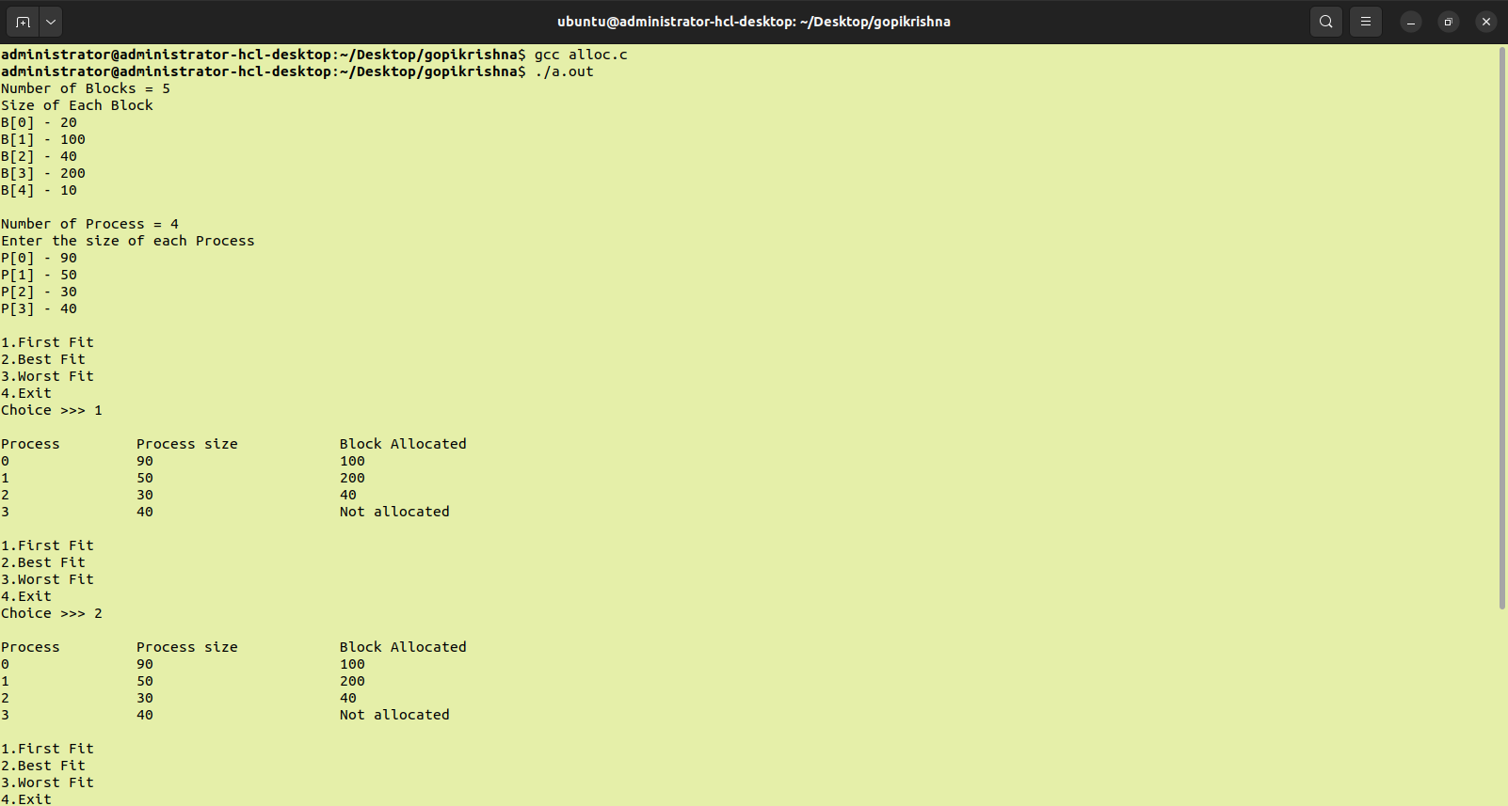
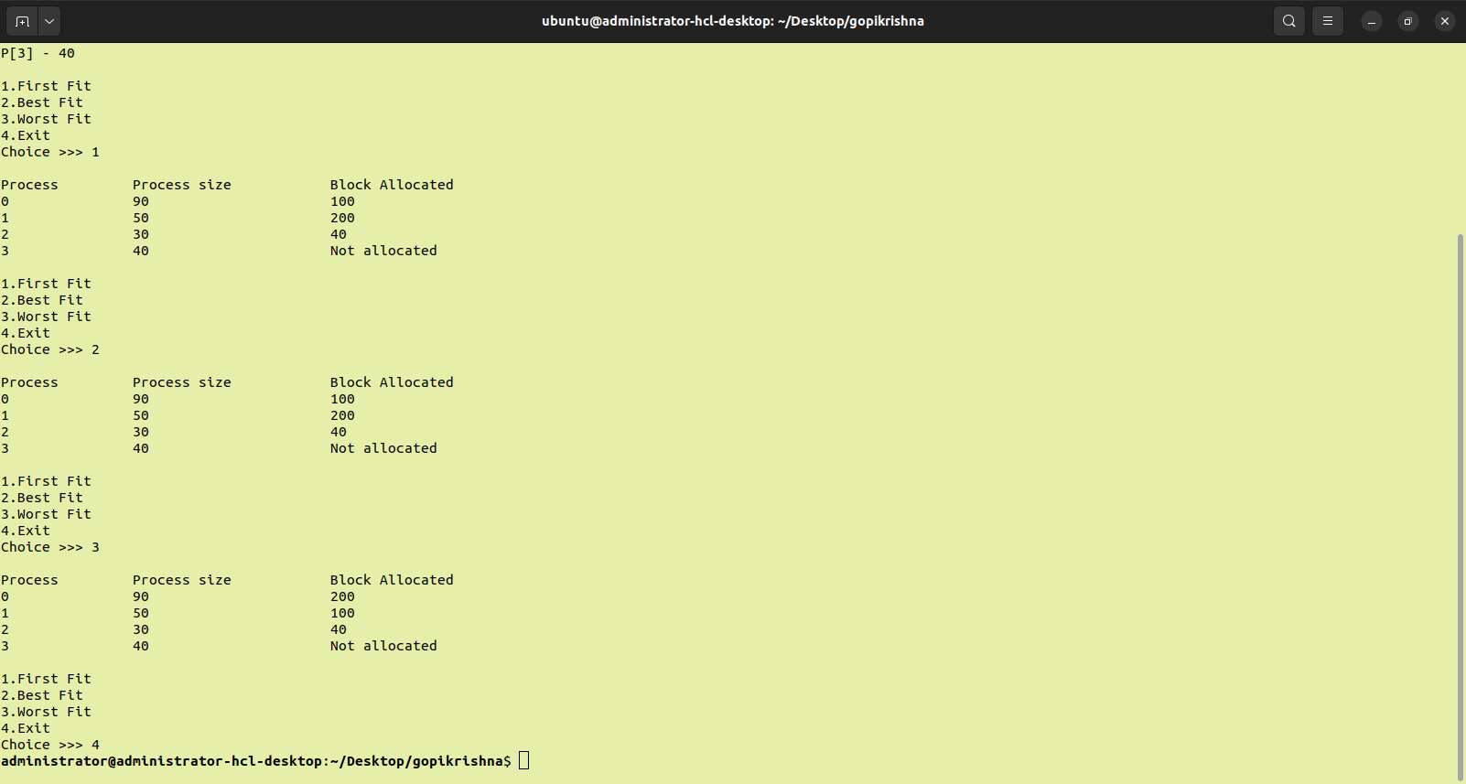
OUTPUT

